Authorization & Security Manager

🔐 What Is the Authorization & Security Manager in a DBMS?
# Source: AI Source: Provided by: [Data Path: Persons Table -> ID Column: 1, Name_En Column: Motasem Essam] -> From: [ChatGPT] on [6/10/2026]
The Authorization & Security Manager is the component of a Database Management System (DBMS) responsible for controlling access to data, ensuring that only authorized users can view, modify, or manage specific parts of the database.
In short: It protects your data from unauthorized access, abuse, and accidental damage.

🧩 Key Responsibilities
# Source: AI Source: Provided by: [Data Path: Persons Table -> ID Column: 1, Name_En Column: Motasem Essam] -> From: [ChatGPT] on [6/10/2026]
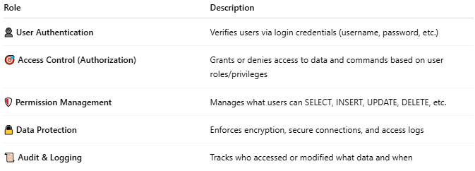
Role | Description
👤 User Authentication | Verifies users via login credentials (username, password, etc.)
🎯 Access Control (Authorization) | Grants or denies access to data and commands based on user roles/privileges
🛡️ Permission Management | Manages what users can SELECT, INSERT, UPDATE, DELETE, etc.
🔒 Data Protection | Enforces encryption, secure connections, and access logs
📜 Audit & Logging | Tracks who accessed or modified what data and when

✅ Common Access Control Levels
# Source: AI Source: Provided by: [Data Path: Persons Table -> ID Column: 1, Name_En Column: Motasem Essam] -> From: [ChatGPT] on [6/10/2026]
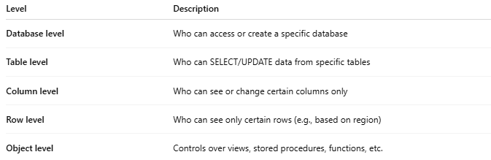
Level | Description
Database level | Who can access or create a specific database
Table level | Who can SELECT/UPDATE data from specific tables
Column level | Who can see or change certain columns only
Row level | Who can see only certain rows (e.g., based on region)
Object level | Controls over views, stored procedures, functions, etc.

🔐 Common Security Mechanisms
# Source: AI Source: Provided by: [Data Path: Persons Table -> ID Column: 1, Name_En Column: Motasem Essam] -> From: [ChatGPT] on [6/10/2026]
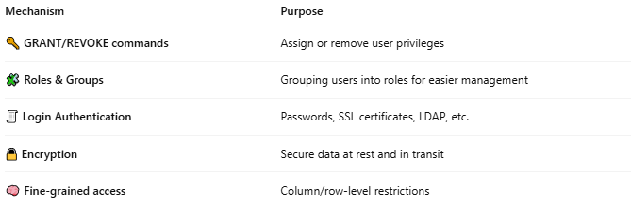
Mechanism | Purpose
🔑 GRANT/REVOKE commands | Assign or remove user privileges
🧩 Roles & Groups | Grouping users into roles for easier management
🧾 Login Authentication | Passwords, SSL certificates, LDAP, etc.
🔒 Encryption | Secure data at rest and in transit
🧠 Fine-grained access | Column/row-level restrictions

🛠️ In Popular DBMSs
# Source: AI Source: Provided by: [Data Path: Persons Table -> ID Column: 1, Name_En Column: Motasem Essam] -> From: [ChatGPT] on [6/10/2026]
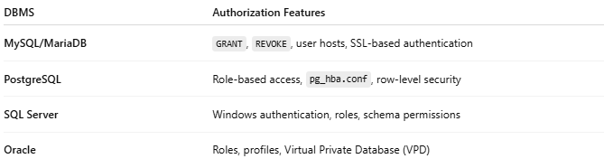
DBMS | Authorization Features
MySQL/MariaDB | GRANT, REVOKE, user hosts, SSL-based authentication
PostgreSQL | Role-based access, pg_hba.conf, row-level security
SQL Server | Windows authentication, roles, schema permissions
Oracle | Roles, profiles, Virtual Private Database (VPD)

⚠️ Why It Matters
# Source: AI Source: Provided by: [Data Path: Persons Table -> ID Column: 1, Name_En Column: Motasem Essam] -> From: [ChatGPT] on [6/10/2026]
- 🔒 Prevents data breaches
- 📛 Stops unauthorized changes
- 🧑‍💼 Supports multi-user environments
- 🧾 Enables compliance (e.g., GDPR, HIPAA)

🧪 Example
# Source: AI Source: Provided by: [Data Path: Persons Table -> ID Column: 1, Name_En Column: Motasem Essam] -> From: [ChatGPT] on [6/10/2026]
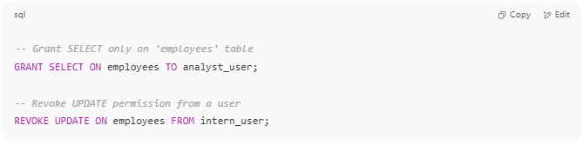
-- Grant SELECT only on 'employees' table
GRANT SELECT ON employees TO analyst_user;

-- Revoke UPDATE permission from a user
REVOKE UPDATE ON employees FROM intern_user;

📌 Summary
# Source: AI Source: Provided by: [Data Path: Persons Table -> ID Column: 1, Name_En Column: Motasem Essam] -> From: [ChatGPT] on [6/10/2026]
The Authorization & Security Manager controls who can access what, enforces permissions, and keeps your database secure and compliant. It is essential for data integrity, privacy, and system safety.

